**Project Design Phase-II**

**Data Flow Diagram & User Stories**

|  |  |
| --- | --- |
| Date | 03 October 2022 |
| Team ID | PNT2022TMID15315 |
| Project Name | Project – Web phishing detection |
| Maximum Marks | 4 Marks |

**Data Flow Diagrams:**

A Data Flow Diagram (DFD) is a traditional visual representation of the information flows within a system. A neat and clear DFD can depict the right amount of the system requirement graphically. It shows how data enters and leaves the system, what changes the information, and where data is stored.

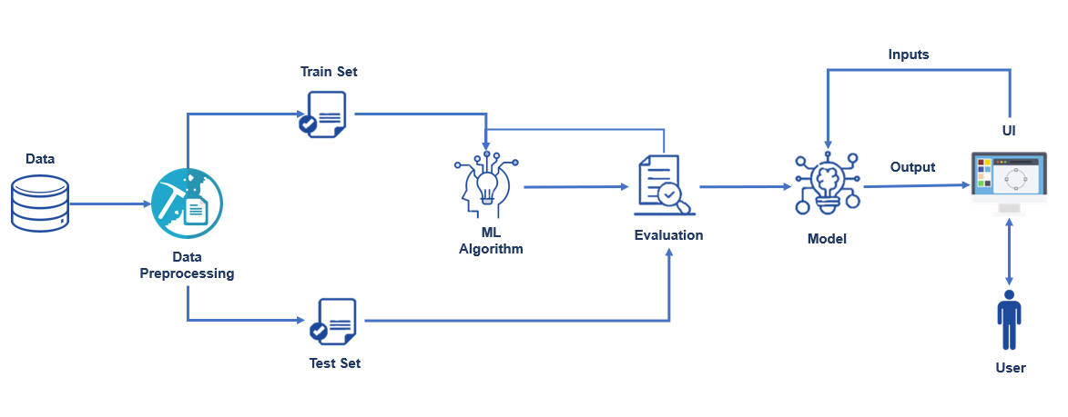

**Web Phishing Detection:**

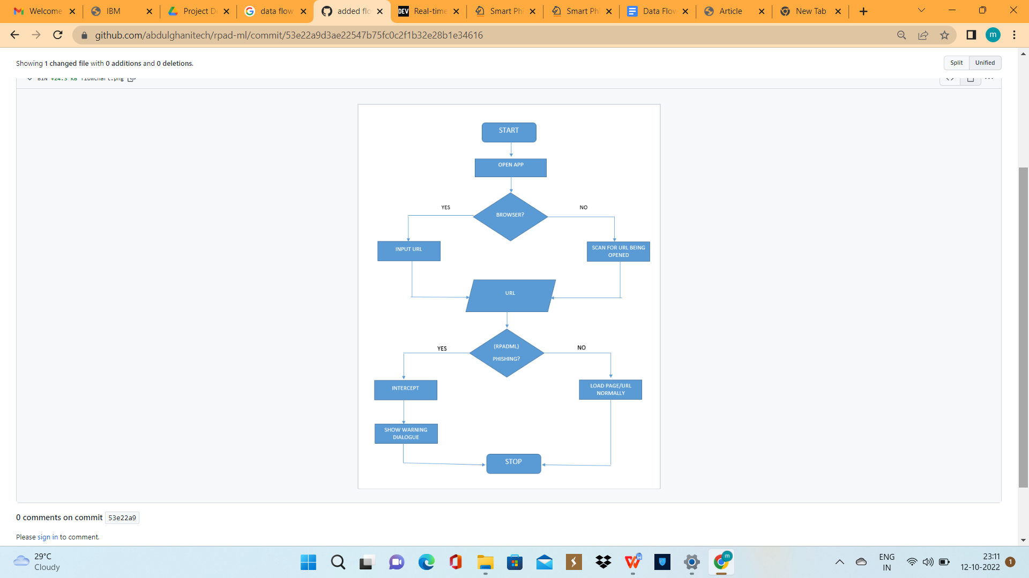

**User Stories:**

Use the below template to list all the user stories for the product.

| **User Type** | **Functional Requirement (Epic)** | **User Story Number** | **User Story / Task** | **Acceptance criteria** | **Priority** |
| --- | --- | --- | --- | --- | --- |
| Customer (Mobile user) | Download the intelligent system | USN-1 | As a user, I can download the intelligent system and detect phishing websites.  The system starts working immediately once you start the computer. | I can download it easily from internet. | High |
|  | register | USN-2 | As a user, I will register for the system using my mail and receive confirmation email once I have registered for the application | I can receive confirmation email & click confirm | Medium |
|  | login | USN-3 | As a user, I can login to the application and enter my details and use the application. | I can Login and give my details | Medium |
|  | Provide access | USN-4 | The user should provide access to google and the user’s search engine so that the intelligent system can detect phishing websites. | I have to provide access to search engines | High |
|  | use | USN-5 | The user can use the intelligent system to detect phishing website | Finally I can use the intelli Medium  -gent system | |
| Customer (Web user) | The functional requirements are same as mobile user. | Same as mobile user | Same as mobile user | Same as mobile user | High when compared to mobile users |